Name: **ZOHAIB HASSAN SOOMRO**

RollNo#: **19SW42**

Subject: **Computer Networking**



1. Execute the show version command on CISCO Packet Tracer to answer the following questions:

**Show version command’s output:**

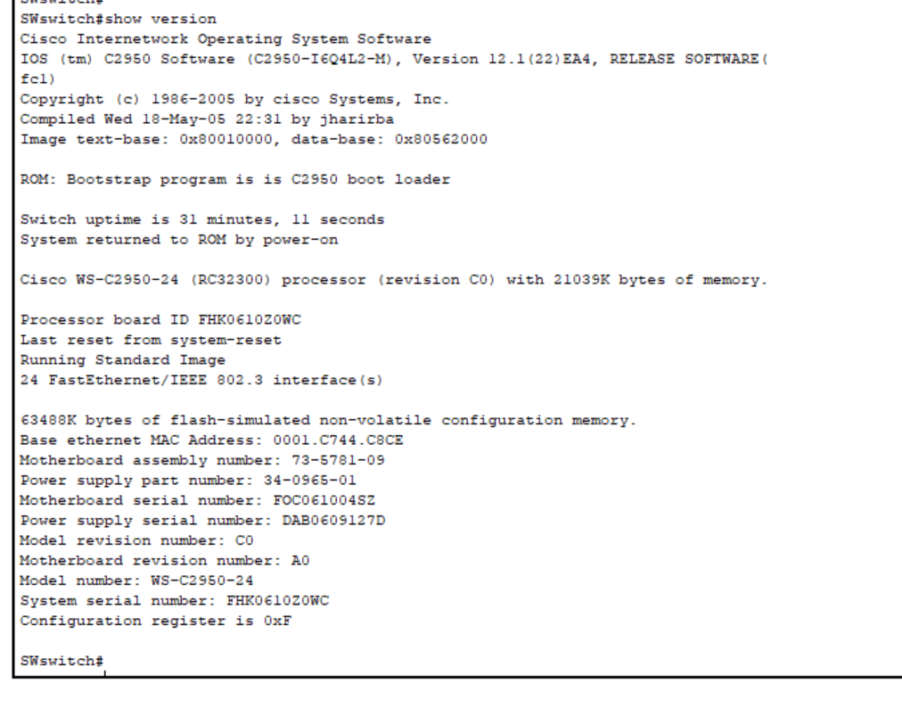

* What is the IOS version?

**IOS (tm) C2950 Software (C2950-I6Q4L2-M), Version 12.1(22)EA4, RELEASE SOFTWARE(fc1)**

* Where was the router IOS image booted from?

**Image text-base: 0x80010000, data-base: 0x80562000**

* What type of processor (CPU) and how much RAM does this router have?

**Cisco WS-C2950-24 (RC32300) processor (revision C0) with 21039K bytes of memory**

* How many Ethernet interfaces does this switch have?

**24 FastEthernet/IEEE 802.3 interface(s)**